**Group/Team no: G12**

**Countdown to a special event**

**A mini project report**

***Submitted by***

**Group/Team No: G12/T8**

**Vinay-2310990999**

**Vedik-2310990998**

***in partial fulfillment for the award of the***

***degree of***

**BACHELEOR OF ENGINEERING**

***in***

COMPUTER SCIENCE & ENGINEERING



**CHITKARA UNIVERSITY**

**CHANDIGARH-PATIALA NATIONAL HIGHWAY**

**RAJPURA (PATIALA) PUNJAB-140401 (INDIA)**

October 2023

Page-1

**Front End Engineering-I 23CS002**

**Group/Team no: G12/T8**

**TABLE OF CONTENTS**

| **Sr.no** | **Section** | **Page**  **No.** |
| --- | --- | --- |
| **1.** | Introduction | 3 |
| **2.** | Problem  Statement | 4 |
| **3.** | Technical  Details | 5 |
| **4.** | Key  Features | 6 |
| **5** | Project advantages | 7 |
| **6** | Tags used | 8 |
| **7.** | Results | 9-16 |
| **8.** | Conclusion | 17 |
| **9.** | References | 18 |

**Introduction**

1. **Project introduction**

Everyone loves a countdown! Once we put a time limit on something, we increase the excitement. A ticking clock means there’s going to be a scramble, and some one could miss out: in one word, drama.

We are thrilled to present our "Own Website" named "FINAL COUNTDOWN". Our team members are Vinay and Vedik. A countdown timer is a digital or mechanical device that counts down a specified amount of time, often displayed in minutes, seconds, or hours, until it reaches zero. It's used to measure and display the remaining time for various purposes.

**2. Team Introduction**

This Project is allocated to Team No. 8 of Group 12. The team comprises 2 members-

⮚Vinay (2310990999)

⮚Vedik (2310990998)

Page | 3

**Front End Engineering-I 23CS002**

**Group/Team no: G12/T8**

**Problem Statement**

**countdown to a special event**

The main purpose of a countdown timer is to create a sense of urgency and give the feeling that "time is running out".

Many countdown timer apps offer limited customization options for timer appearance, alert sounds, and notifications. Users have expressed a desire for more personalization features.

Users often lose interest in countdown timers that do not engage them effectively Improving the visual appeal and gamification elements can make timers more appealing.

Many users switch between devices and platforms, such as smartphones, tablets, and computers. Existing timers may not sync seamlessly across these devices or may lack compatibility with different operating systems.

Page | 4

**Front End Engineering-I 23CS002**

**Group/Team no: G12/T8**

**TECHNICAL DETAILS**

**HTML:** HTML provides a structured way to organize content on the web. It allows us to define the different elements of a webpage, such as headings, paragraphs, lists, images, tables, and more. By using HTML tags, we can create a logical structure for our content, making it easier for both humans and search engines to understand.

**CSS:** CSS (Cascading Style Sheets) is a crucial component of web development that is used for styling and visually enhancing web pages. CSS provides a consistent way to apply styles to multiple elements across a website. By defining styles in a central CSS file, we can easily apply the same visual properties (such as colors, fonts, margins, and padding) to multiple elements.

**JavaScript:** JavaScript is a widely used programming language in web development that provides interactivity and dynamic functionality to websites. It can be used to create the exit plugin for our project.

Page | 5

**Key Features**

**Some of the Key Features of These projects are:**

**Final Countdown" can function without an internet connection, allowing users to rely on it in various situations.**

***-Social Media Integration*:**

**1.Sharing Options: Enable users to easily share their countdown on social media platforms.**

**2.Hashtags: Encourage the use of event-related hashtags for community building.**

**-*User Engagement*:**

**1. Interactive Elements: Incorporate interactive elements,such as polls, quizzes, or daily countdown challenges**

**2. Notifications: Allow users to subscribe to notifications forimportant updates or milestones leading up to the event.**

**-"*Final Countdown*" Allow timers to run in the background, even when the app is closed, so users can multitask while keeping track of time**

**Front End Engineering-I 23CS002**

**Group/Team no: G12/T8**

Page-6

**Project advantages**

**The project has several advantages, a few of them are:**

1.User Interactive: This project gives user different well designed specific countdown web pages for different major social events.

2. About Knowledge: This project consists various Wikipedia links for their better understanding of event. These links give users a deep knowledge about event its history and reason for its celebration.

3. Calendar feature: Some webpages have calendar icon which redirect the user to a different webpage having calendar for their convenience and event management.

4. Time management helper: the one of main features of project is countdown which constantly reminds the user the time left for event and help them manage their time in an efficient way.

5. Home Page icon: Some web pages contain a home page icon which redirect the user to home pages.

6. Customizable: This project has custom your countdown page where user can customise their own webpage as per their needs and choices.

Page-7

**Tags used**

**The project has several advantages, a few of them are:**

**1. <!DOCTYPE>:** Specifies the document type and version of HTML being used**.**

2. **<html**>: The root element that contains all other HTML elements on the page.

3. <**head**>: Contains meta-information about the document, such as the title, character set, and

links to external resources.

4. <**title**>: Sets the title of the web page, which is displayed in the browser's title bar or tab.

5. <**meta**>: Provides metadata about the document, such as character encoding, author, and

description.

6. <**link**>: Used to link external resources like stylesheets (CSS) or icons.

7. <**style**>: Defines internal CSS styles for the document.

8. <**body**>: Contains the visible content of the web page, such as text, images, and multimedia.

9. <**h1>, <h2>, <h3>, ... <h6**>: Headings that define the document's structure and hierarchy. <h1>

is the highest level, and <h6> is the lowest.

10. <**p**>: Defines a paragraph of text.

11. <**a>:** Creates hyperlinks to other web pages or resources.

12. <**img**>: Embeds images on the page.

13. <**ul**>: Creates an unordered (bulleted) list.

14. <**ol**>: Creates an ordered (numbered) list.

15. <**li**>: Defines list items within <ul> or <ol>.

16. <**div**>: A generic container for grouping and styling elements.

17. <**span**>: A generic inline container for styling small portions of text.

Page | 8

**Front End Engineering-I 23CS002**

**Group/Team no: G12/T8**

**Results**

**Main web page**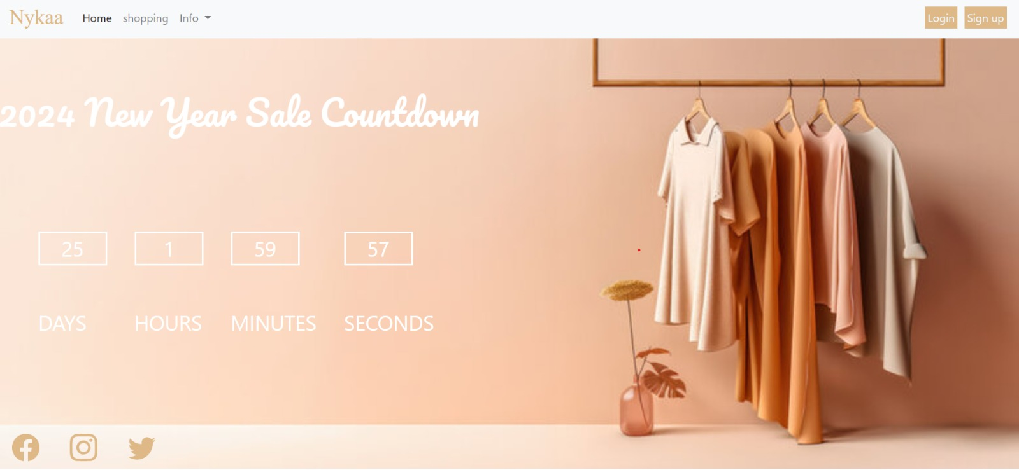

**Main web page source code**

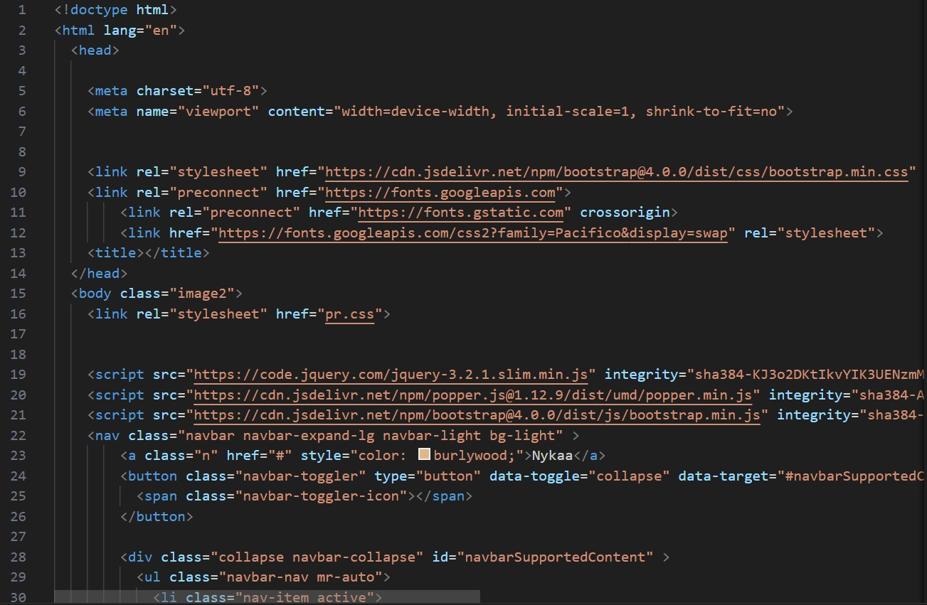

Page-9

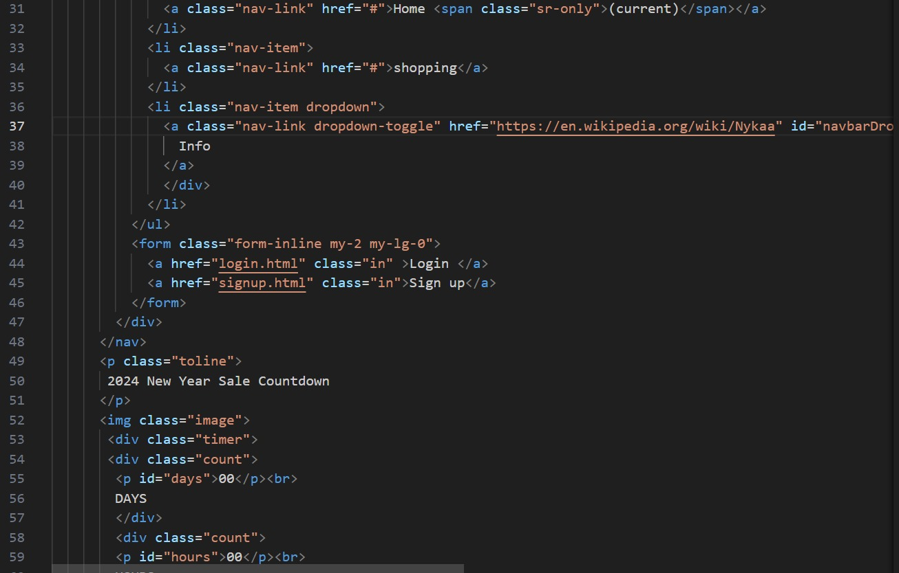

Page-10

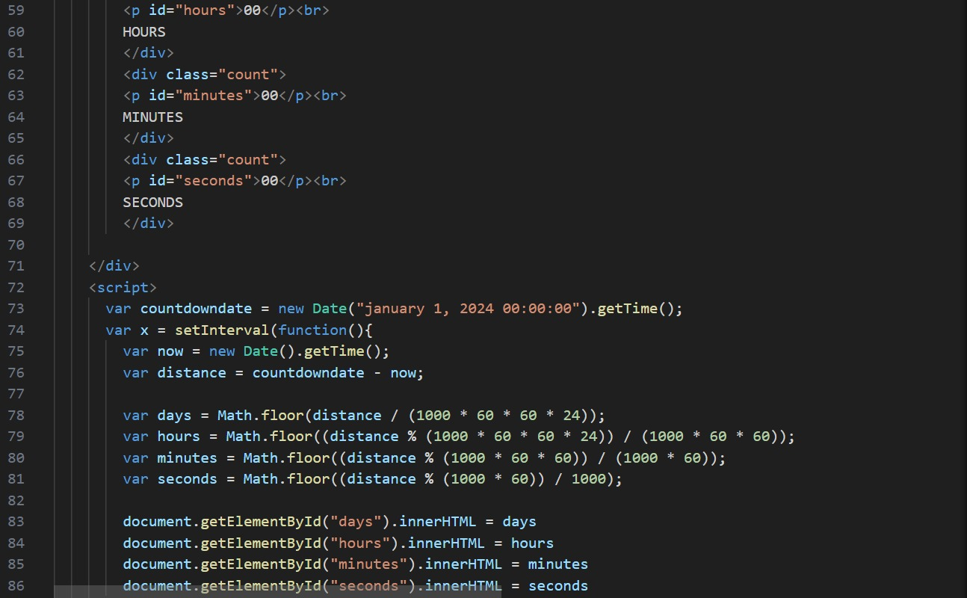 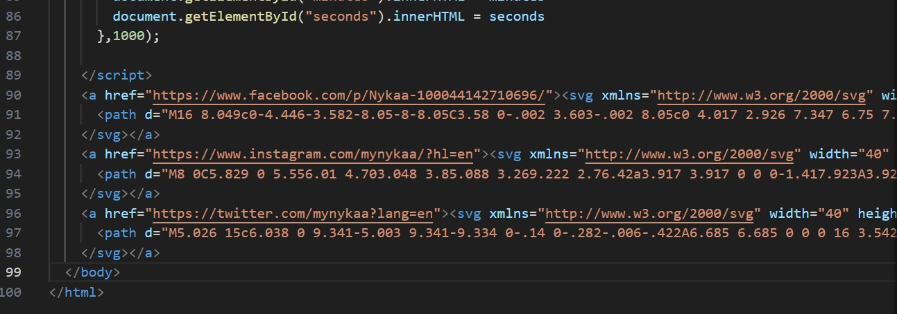

Page-11

**Login page**

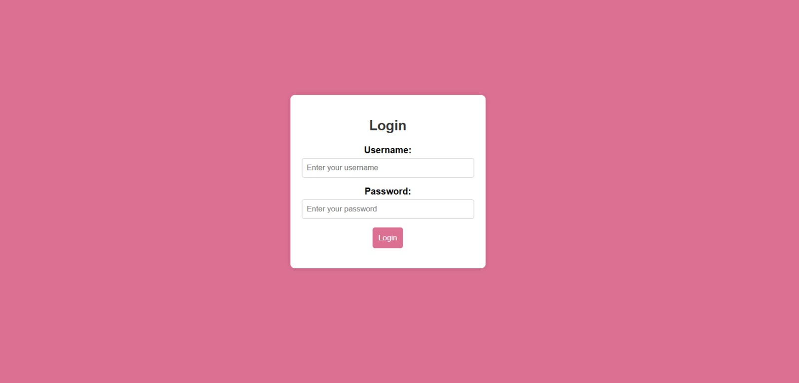

**Login page source code**

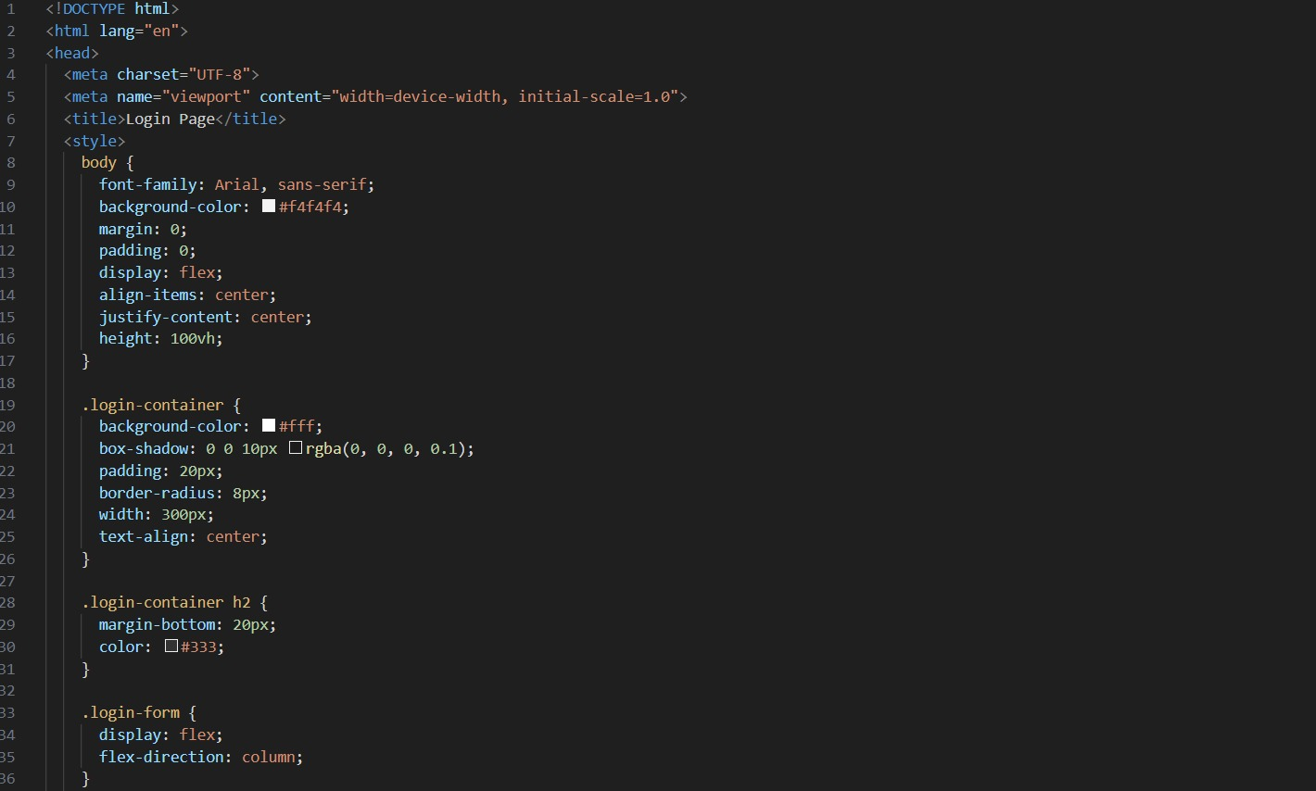

Page-12

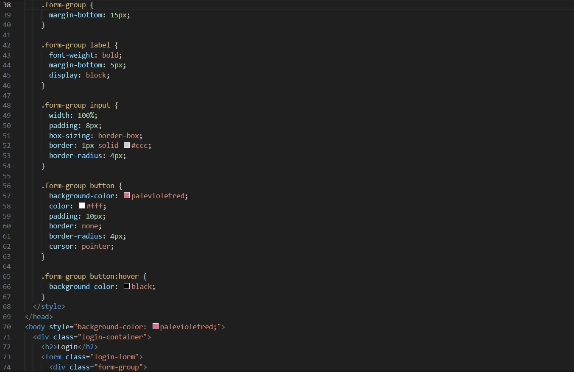

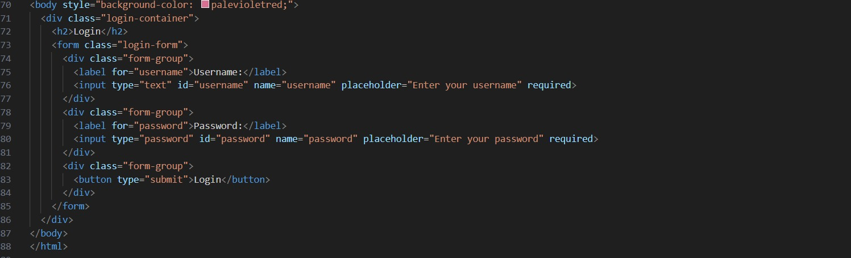

Page-13

**Sign up page**

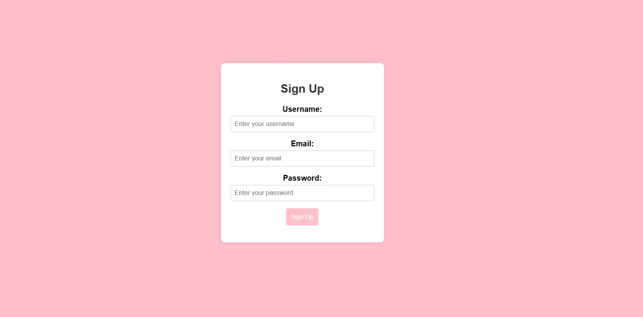

**Sign up source code**

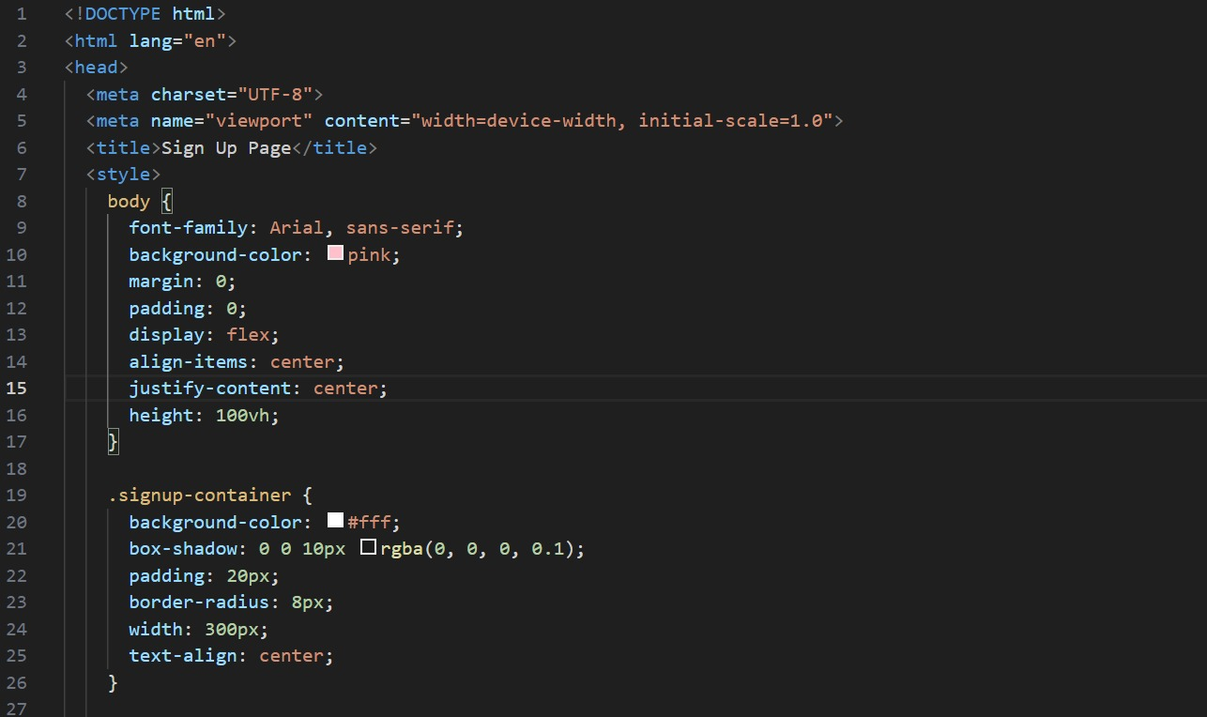

Page-14

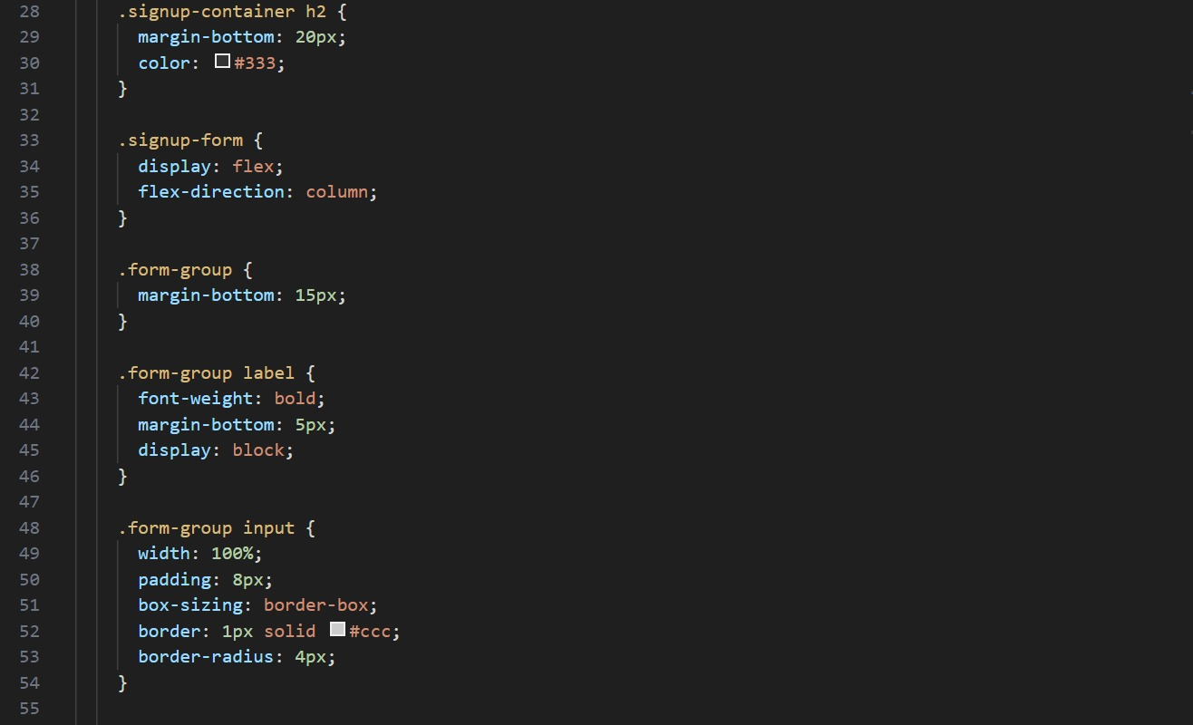

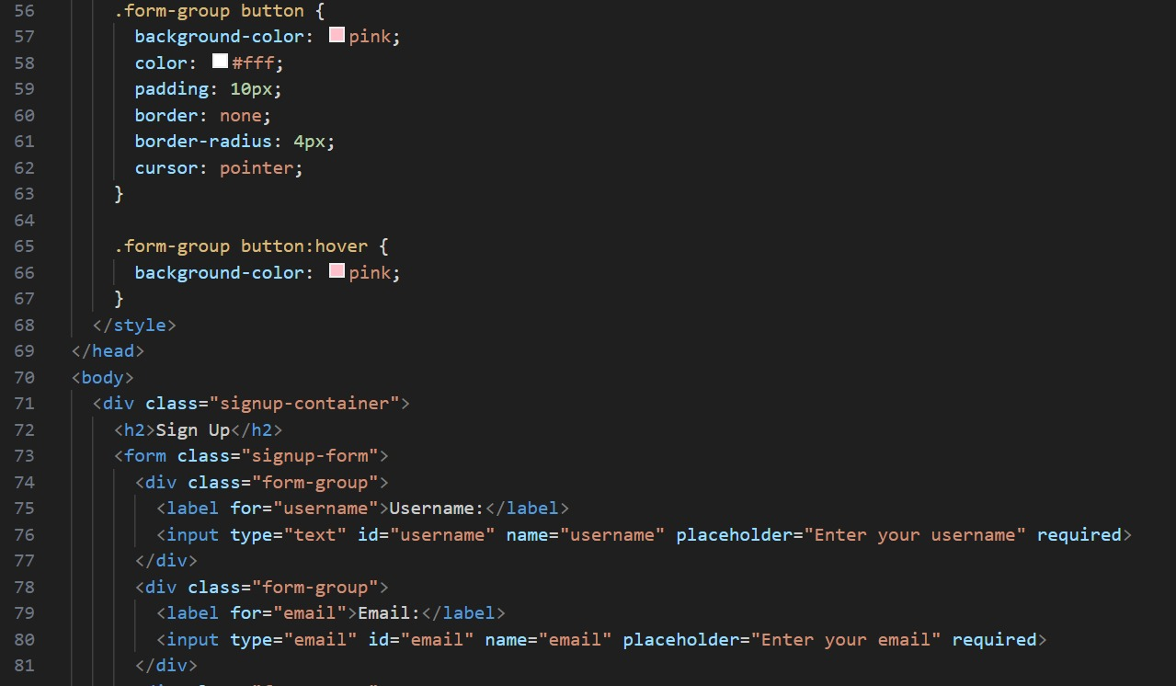

Page-15

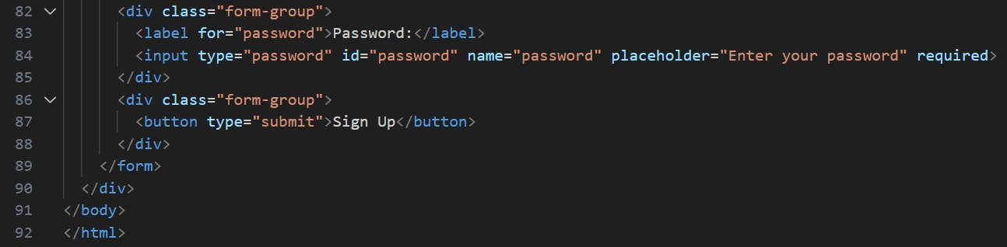

Page-16

**Conclusion**

In conclusion, countdown timers are versatile tools that serve a multitude of purposes in both personal and professional contexts. They help individuals manage their time effectively, enhance productivity, and stay organized. The flexibility of countdown timers is further enriched when bonus features are integrated. These features, such as customizable alerts, interval timers, recurring timers, and progress tracking, cater to diverse user needs and preferences. Whether ticking down to the launch of a product, the start of a special occasion, or the end of a work sprint, these timers symbolize the ticking moments that shape our experiences.

Page-17

**Refrences**

1)https://youtu.be/6311FJdQvoo?feature=shared

2)https://www.w3schools.com/html/html_css.asp

3)https://stackoverflow.com/questions/51596004/pure-css-count down-animation

Page-18